RaspPi Lab 1 – Count Your Instructions

Step 1) Access the Terminal: At the top left of the desktop, click on the icon that looks like a grey box with a white ‘>_’ inside of it.
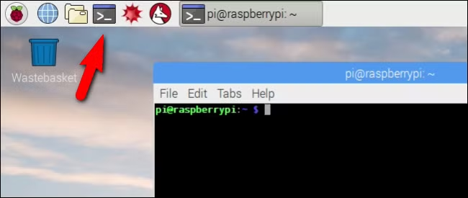

Step 2) Check your CPU: Type `lscpu` in the terminal and Enter

Step 3) Check Memory: Type `cat /proc/meminfo` and Enter

Step 4) Check Storage: Type `df –h` and Enter

Step 5) Show All Files and Sub-Directories in the Current Directory: Type `ls –al` and Enter

Step 6) Navigate the File System
- Move into a directory: Type `cd [the directory you want to go do]` and Enter
- Move back to the last-level of the directory: Type `cd .. ` and Enter

Step 7) Look at the Programs
- Type `geany HOTIS-count-till-py.py` and Enter
- Type `geany HOTIS-count-till-cpp.cc` and Enter
- Then let’s dissemble the object file: Type `objdump –d HOTIS-count-till-cpp.o` and Enter

Step 8) Run the Programs
- Type `python HOTIS-count-till-py.py <A number of your choice >` then Enter
- Type `./HOTIS-count-till-cpp.out <A number of your choice >` then Enter
- Game: How many machines instructions do you think the program executed?

Step 9: Count the Machine Instructions
- Type `perf stat -e instructions:u python HOTIS-count-till-py.py <A number of your choice >` then Enter
- Type `perf stat -e instructions:u ./HOTIS-count-till-cpp.o <A number of your choice >` then Enter
- Who got the closest? Any surprise?

Step 10) Shut Down the RaspberryPi
- DO NOT UNPLUG THE PI WHILE IT’S ON!
- If you’ve ever done this on Windows, you may have seen a startup repair screen when you booted up the PC next. We don’t have that, so it can corrupt the file system in the OS.
- Type `shutdown now` then Enter

